1. 打開瀏覽器
2. 進入網址：主分板 <http://sparring.chiloktkd.com/>
3. 裁判手掣<http://sparring.chiloktkd.com/refereeLogin.php>

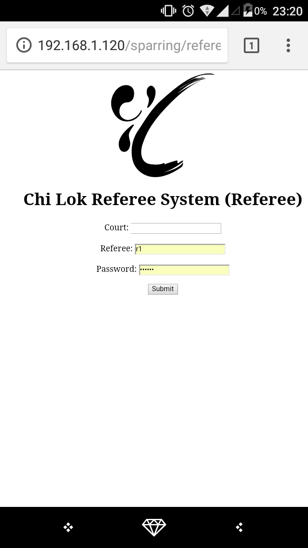

1. court 為：自定義
2. 根據座位輸入Referee (r1 / r2* / r3)

|  |  |  |
| --- | --- | --- |
| r1 |  | r3 |
|  |  |  |
|  | r2 |  |

1. 是次密碼為：chilok

*1 Referee mode account